Pisces User Guide

# Loading a File into the program

1. Select the appropriate category tab out of the 4 options:
   * Teaching, Publications, Presentations, Grants and Clinical Funding



1. Press the “Load File Button” and the file explorer will popup.
   * Alternatively, one can press “Control + L” or simply drag and drop a file into the program.

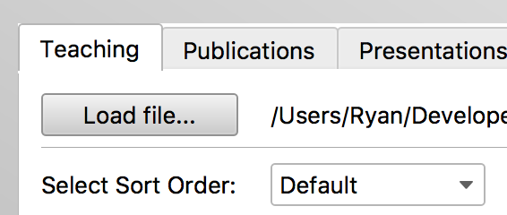

1. Select the file you want to load in the file explorer and press “Open”



1. The next time you reopen the program. The system will prompt you to re-open the last file you had open.

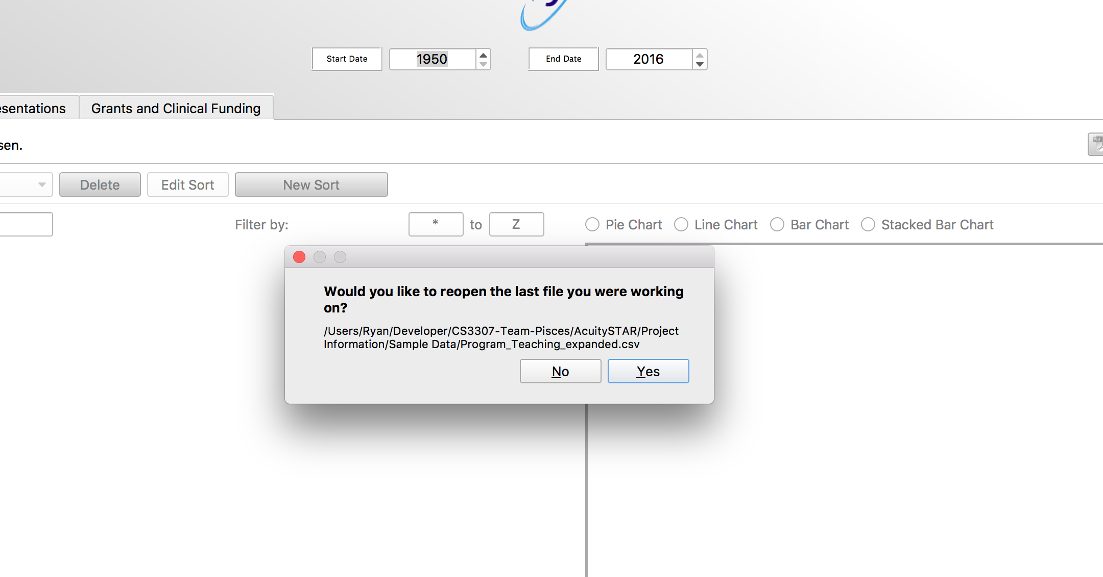

# Handling Error Fields

1. If your data file has any fields missing. You will be prompted to either edit the fields missing data or discard the row containing the missing fields completely.

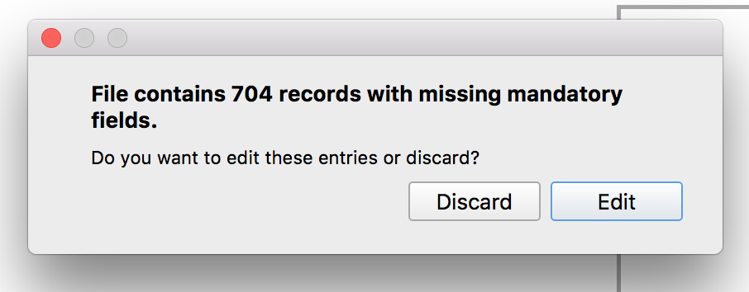

1. If you press the Discard button the error rows will be removed and your data will display in the table.

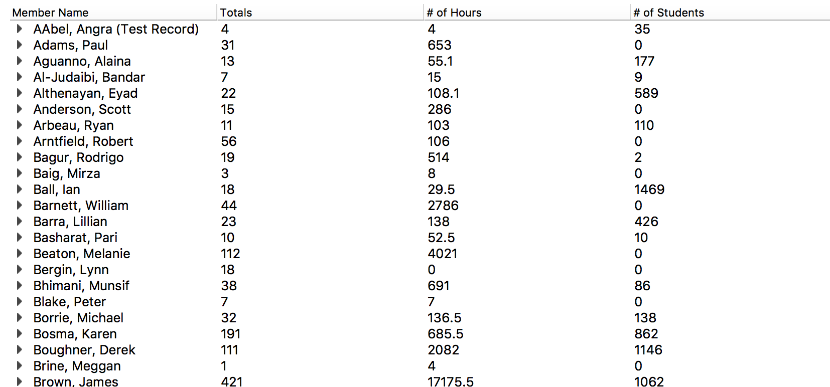

1. If you press the Edit button. You will be brought to the Error Editor which will prompt you to edit and fix the cells missing data.
   * The cells missing data will be highlighted in red.
   * The cells that have been fixed will be highlighted in green.
   * You may use the Prev and Next button to jumpt to the Previous and Next error field in the file.

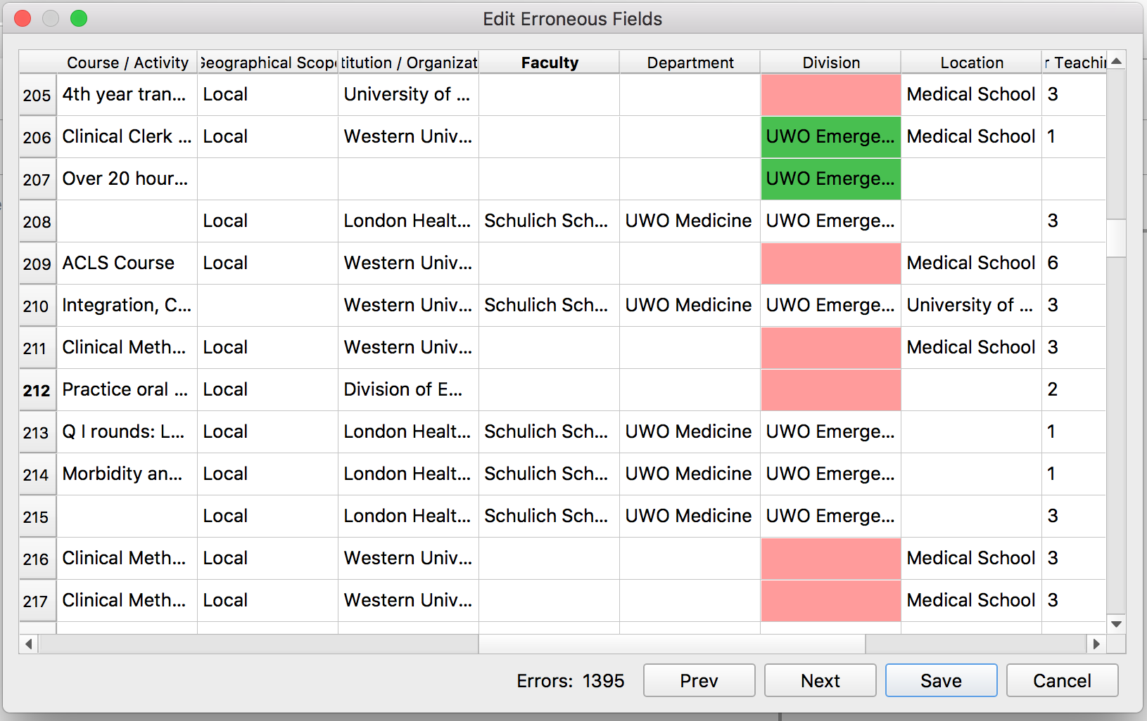

1. Once you have finished filling in all the error fields you may press the “Save” button to display the edited data in the table.
2. At any point, you may press the “Cancel” button to discard the fields with errors and just show the valid rows in the table.

# Sorting and Searching Through Data

1. The Pisces Galaxy System has several methods to sort/search through the data.



1. You can search for a specific record using the “Search Records” text field

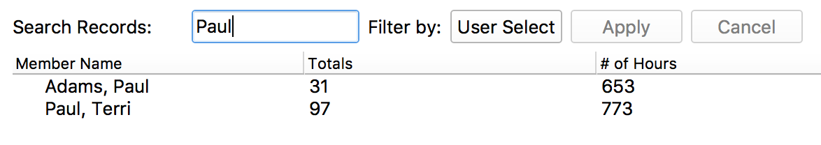

1. To sort by a user selected list:
   * Press “User Select”

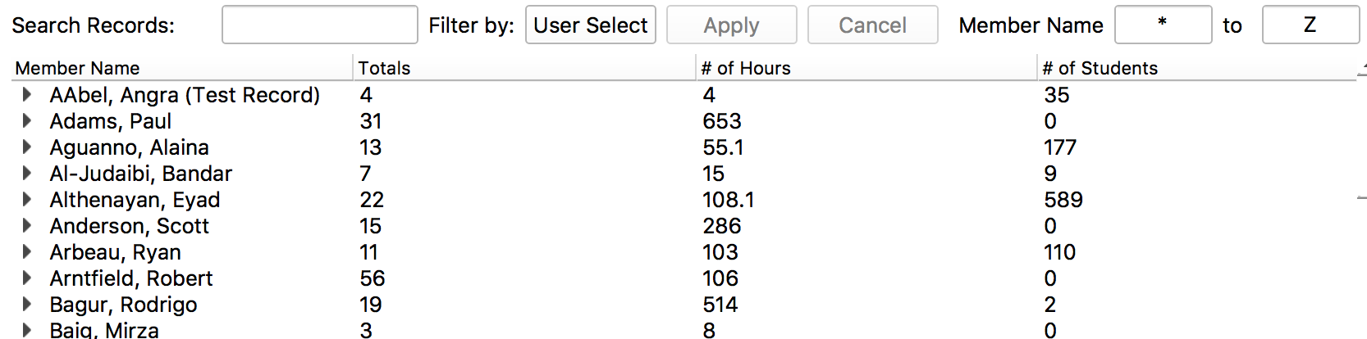

* + “Select your list”

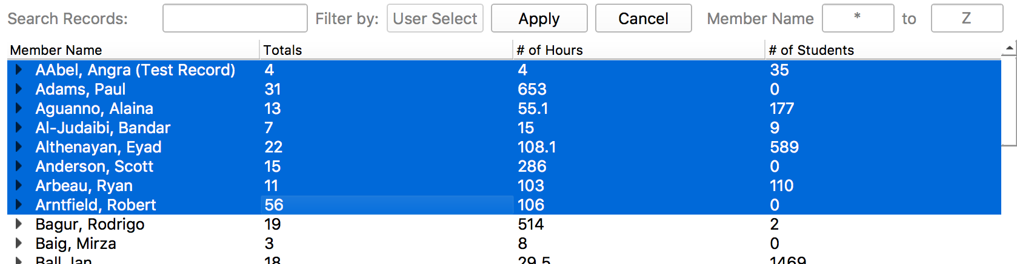

* + “Click Apply to filter list to only the names you had selected”

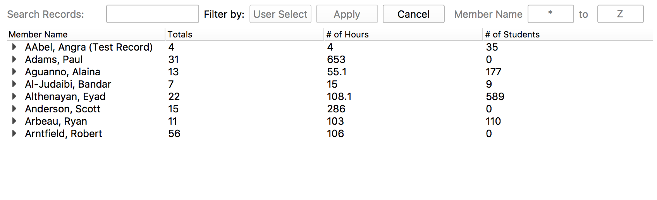

* + Once you are finished using your user selected list make sure to press the “Cancel” button.

1. Or to create your own custom sort order press the “New Sort” button

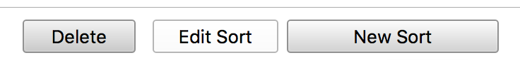

* + You can then select which fields you want to sort by and press save

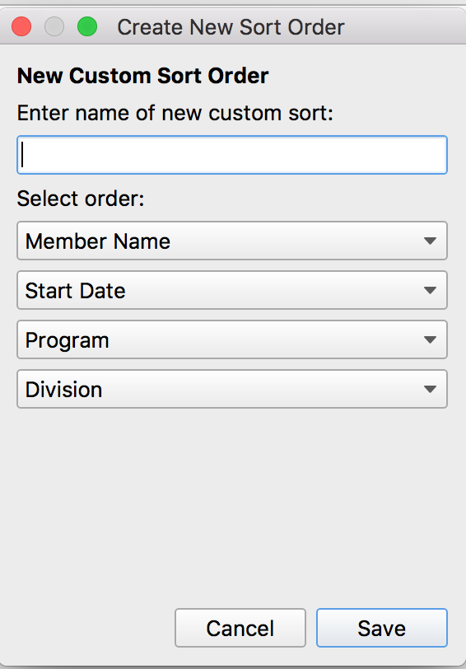

* + Then select your sort in the sort order dropdown to apply it to the dataset

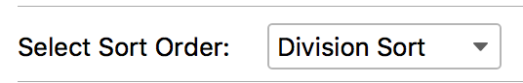

* + At any time if you want to edit/change your sort order you can press the “Edit Sort” button
  + You can also delete your newly made Sort Order by pressing the “Delete” Button

# Visualizing Data

1. To display a graph, you must first select a data item in the table.



1. You can then view any of the four different graph types by selecting the appropriate radio button.

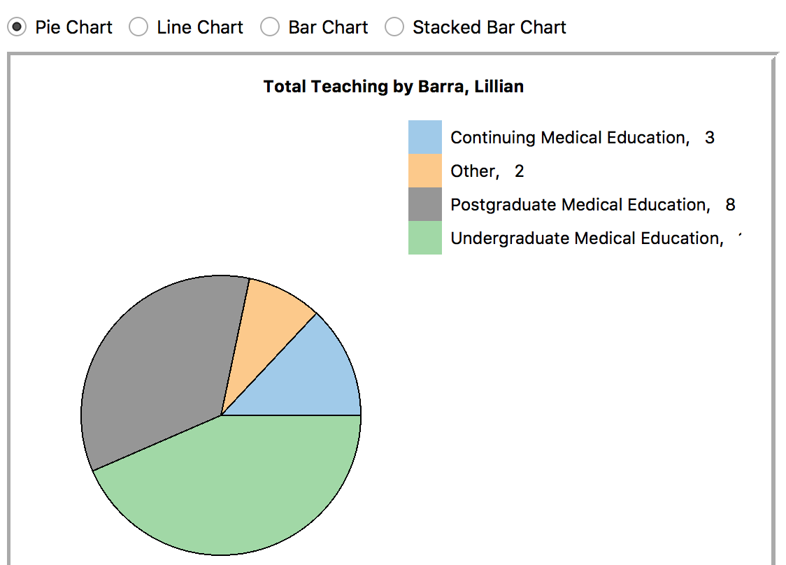

1. Once you have selected a chart you can Print / Export a graph by pressing the “Print” or “Export” button
   * You can also press “Control + P” to Print
   * Or “Control + E” to Export the file to a pdf

